1)CREATE TABLE 19pw28_employee(

name varchar(15),

Designation varchar(15),

Dept varchar(15),

Salary int,

phonenumber bigint(10)

);

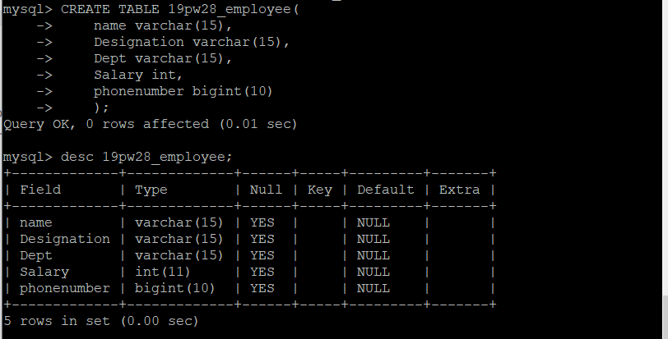

2)ALTER TABLE 19pw28_employee ADD id int NOT NULL FIRST;

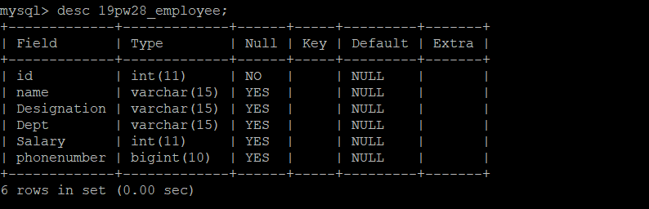

3)ALTER TABLE 19pw28_employee ADD city varchar(15) AFTER salary,

ADD Last_name varchar(15) AFTER name;

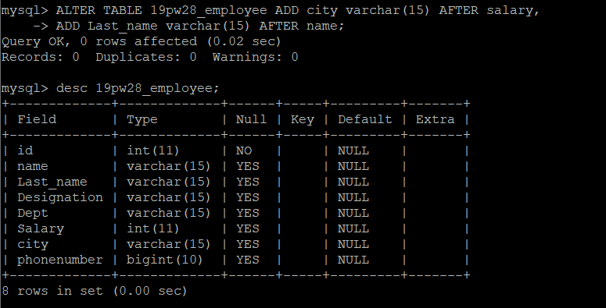

4) ALTER TABLE 19pw28_employee MODIFY Last_name varchar(20) not null;

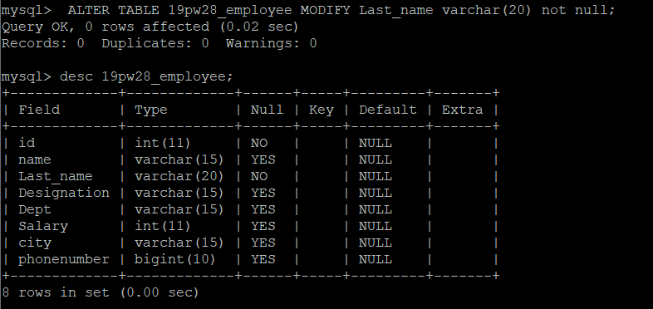

5)ALTER TABLE 19pw28_employee ADD Date_of_joining date NOT NULL;

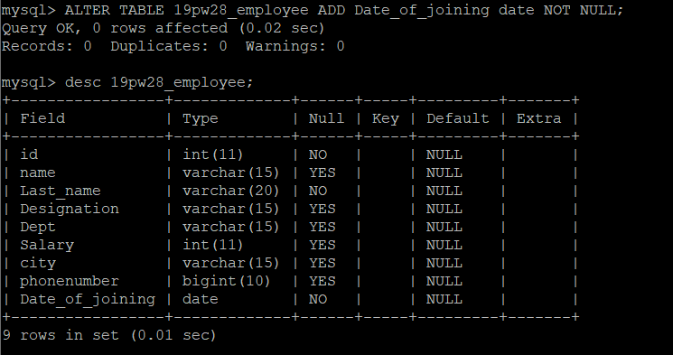

6) ALTER TABLE 19pw28_employee CHANGE id EID int;

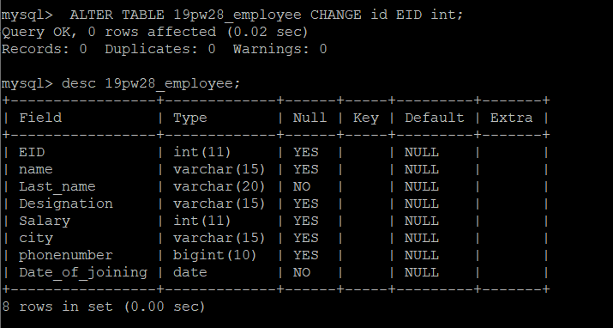

7)ALTER TABLE 19pw28_employee MODIFY city varchar(15) NOT NULL;

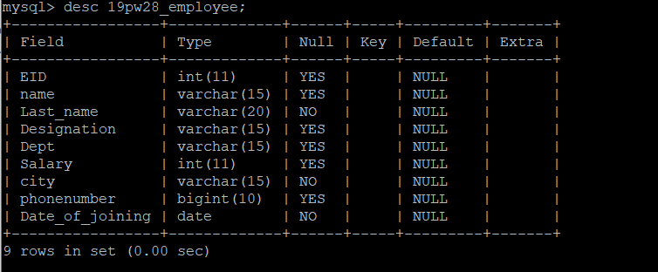

8) ALTER TABLE 19pw28_employee DROP COLUMN Last_name;

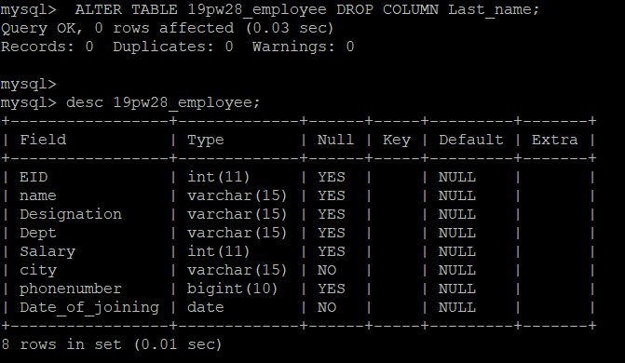

9) CREATE TABLE IF NOT EXISTS 19pw28_dup_employee LIKE 19pw28_employee;

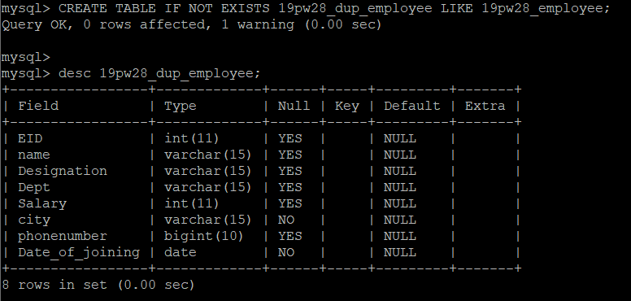

10) ALTER TABLE 19pw28_employee RENAME TO 19pw28_employee_data;

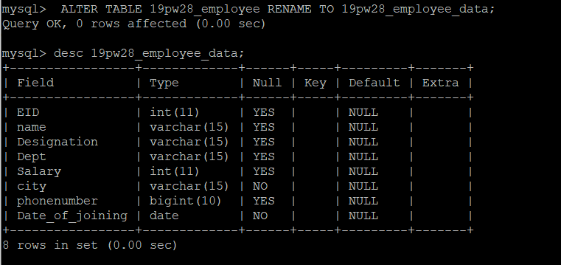

11)DROP TABLE 19pw28_dup_employee;

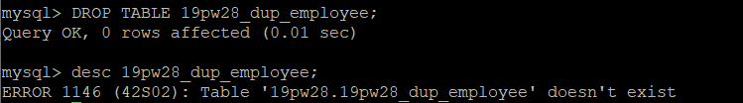

12) show columns from 19pw28_employee_data;

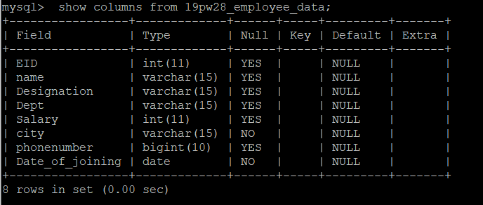

13)INSERT INTO 19pw28_employee_data(EID, name, Designation, Dept, salary, city, phonenumber, Date_of_joining)

VALUES (101, 'Smith', 'Manager', 'Accounts', 20000, 'Chennai', 9290249125, '1980-12-27'),

(407, 'Allen', 'Clerk', 'Accounts', 5000, 'Coimbatore', 9945533992, '1981-06-09'),

(678, 'Scott', 'Lecturer', 'ECE', 30000, 'Trichy', 9965542211, '1980-05-01');

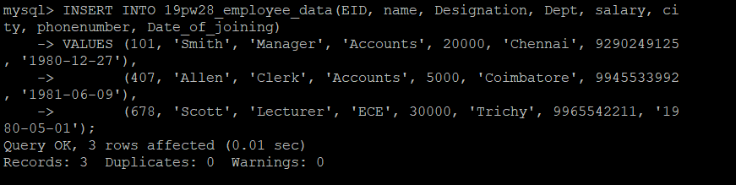

14) TRUNCATE TABLE 19pw28_employee_data;



15) ALTER TABLE 19pw28_employee_data MODIFY EID int unique NOT NULL;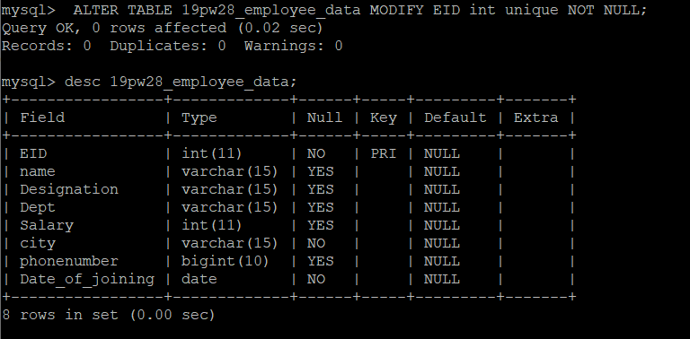

16)INSERT INTO 19pw28_employee_data(EID, Name, Designation, Dept, Salary, city, phonenumber, Date_of_joining)

VALUES (101, 'Smith', 'Manager', 'Accounts', 20000, 'Chennai', 9290249125, '1980-12-27'),

(407, 'Allen', 'Clerk', 'Accounts', 5000, 'Coimbatore', 9945533992, '1981-06-09'),

(678, 'Scott', 'Lecturer', 'ECE', 30000, 'Trichy', 9965542211, '1980-05-01'),

(747, 'Jones', 'Professor', 'Maths', 35000, 'Coimbatore', 9946673321, '1999-11-12'),

(690, 'Adams', 'Professor', 'EEE', 50000, 'Vellore', 9866544332, '1979-05-25'),

(579, 'Miller', 'Lecturer', 'ECE', 25000, 'Chennai', 9955778890, '1999-12-24'),

(671, 'Ram', 'Asst. professor', 'EEE', 48000, 'Chennai', 9877466335, '1980-10-09'),

(745, 'Allex', 'Senior lecturer', 'ECE', 46000, 'Trichy', 9942266788, '1999-08-19'),

(742, 'Arjun', 'Professor', 'EEE', 48000, 'Coimbatore', 9977886765, '1999-12-06'),

(749, 'Robert', 'Lecturer', 'EEE', 30000, 'Coimbatore', 9866778855, '2005-01-17'),

(845, 'Smyth', 'Clerk', 'Accounts', 9000, 'Salem', 9900007722, '1973-12-31');

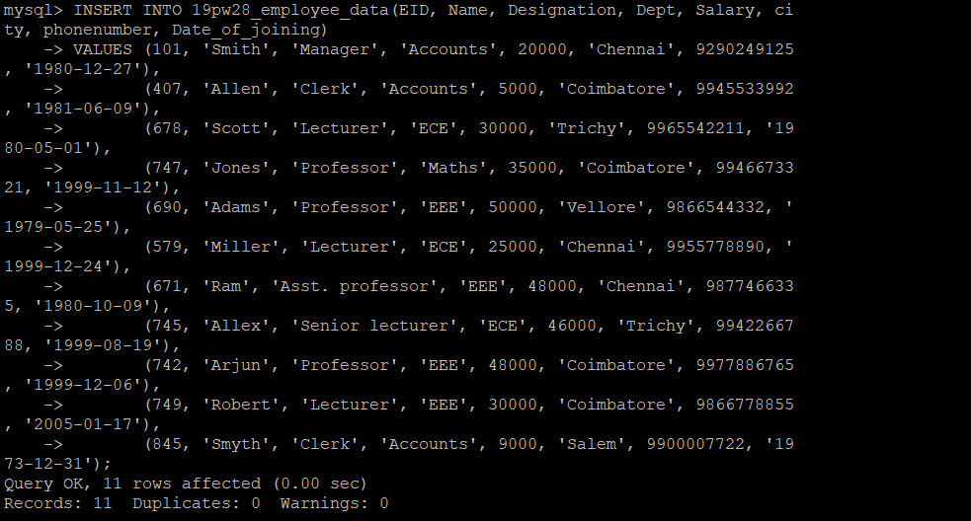

17) CREATE TABLE 19pw28_CBE_employees AS SELECT * FROM 19pw28_employee_data WHERE city='coimbatore';

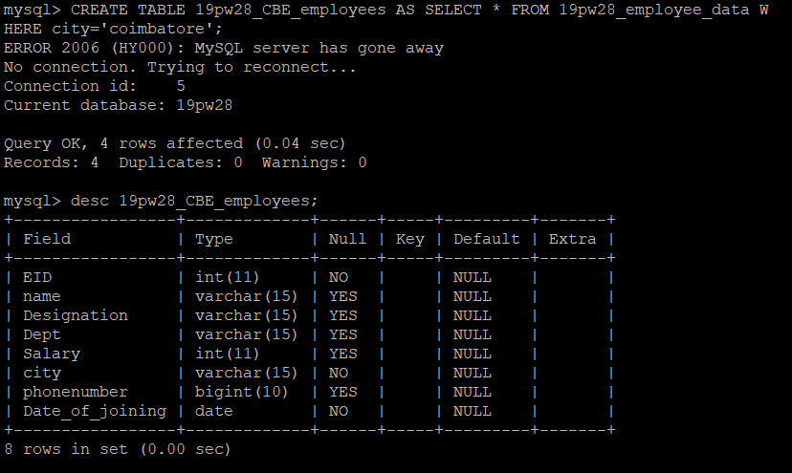

18)CREATE TABLE 19pw28_Subset_employees AS (SELECT EID, name, Designation, phonenumber FROM 19pw28_employee_data);

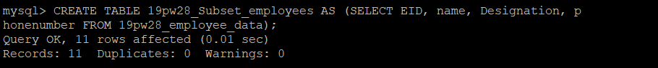

19)ALTER TABLE 19pw28_employee_data

ADD CONSTRAINT Dept_check CHECK (Dept IN ('Accounts', 'ECE', 'EEE', 'Maths'));

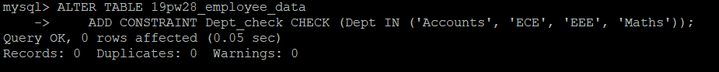

20)ALTER TABLE 19pw28_employee_data

ADD CONSTRAINT Salary_check CHECK (Salary >= 5000 AND Salary <= 50000);

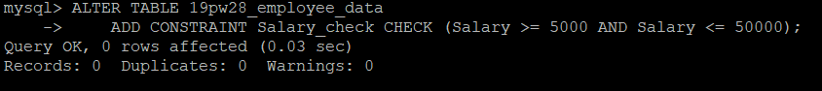

21)ALTER TABLE 19pw28_employee_data

MODIFY COLUMN phonenumber BIGINT(10) NOT NULL UNIQUE;

